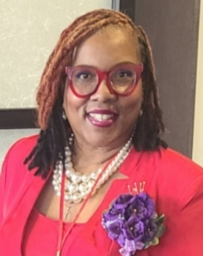
Born and raised between Coney Island, New York, and North Carolina, Godzetta Whittington brings over 30 years of experience as a dedicated educator. Throughout her career, she has remained committed to the belief that all children can learn and thrive when given the right support and opportunities. As a proud board member of SBM, Godzetta supports the organization’s mission to help young people connect with and celebrate their cultural heritage through transformative conferences and mentorship.

